ANNEX 04 – USER REQUIREMENTS

The Bidder should provide the following in the specified order in Section 4 of the proposal/bid document.

Provide detail information of the proposed solution as per document enclosed. Please note that marking should be carried out in the following manner; The Remarks column should be used to explain or provide detail information.

DESCRIPTION | REMARKS
Rating - 5 | If the User requirement is met 100% as defined in the RFP without any work around method.
Rating - 4 | If the User requirement is met 75% as defined in the RFP without any work around method. Define the number of hours required for the modification and cost in US$ in the Remarks column, inorder to provide 100% functionality as defined.
Rating - 3 | If the User requirement is met 50% as defined in the RFP without any work around method. Define the number of hours required for the modification and cost in US$ in the Remarks column, inorder to provide 100% functionality as defined.
Rating - 2 | If the User requirement is met 25% as defined in the RFP without any work around method. Define the number of hours required for the modification and cost in US$ in the Remarks column, inorder to provide 100% functionality as defined.
Rating - 1 | If the User requirement is met as a Work around method defined in the RFP. Define the number of hours required for the modification and cost in US$ in the Remarks column, inorder to provide 100% functionality as defined.
Rating - 0 | If the User requirement is not met as a defined in the RFP and modifications are required. Define the number of hours required for the modification and costs in US$ in the Remarks column.
The NBL rating is as follows:
1 = critical ; 2 = essential; 3 = nice to have

USER REQUIREMENTS (IN ADDITION TO WHAT IS CURRENTLY AVAILABLE IN THE SYSTEM) MODULE : CRM

Ref | Requirements | NBL Priority | Bidder Rating | Bidder’s Remarks
 | Exposures | 1
 | Single customer view  Ability to arrive at Exposures of an individual or Groups of customers in one single view with breakdown of customer wise, product wise, rating wise, sector wise exposures and outstanding for the entire bank. |  | 5 | Handled by the Central Liability functionality of T24. The Exposure enquiry display can be included into the Single Customer View composite screen.
2. | Portfolio | 1
 | - For all products with rating on a combined basis (Commercial Banking division & Project Finance, SCM, Auto Finance, EC). This also to facilitate account profitability, collection ratios, infection ratios |  | 4 | Minor customization is required because the various ratios are local NDB specifics.
 | - Sector Basis, including all products and on a combined basis. This also to facilitate rating, account profitability, collection ratios and infection ratios |  | 4 | Minor customization is required because the various ratios are local NDB specifics.
 | - Group basis, including all products and on a combined basis. This also to facilitate rating, sector classification, account profitability, collection ratios, infection ratios) |  | 4 | Minor customization is required because the various ratios are local NDB specifics.
 | - Enquiry to list all clients under a particular risk rating (for all products). (At present the entire portfolio needs to downloaded & sorted product wise) |  | 5 | Handled by similar standard T24 enquiries and reports.
3. | Disbursement & Loan Maturity details | 1
 | - Need to have a system to monitor disbursement details in summary form under different contract of customers for monitoring purposes.  - To be able to obtain a report on the loan maturities with fields such as client name, current o/s, approved date & maturity date |  | 5 | Supported by similar standard T24 enquiries and reports, one of which is shown below:  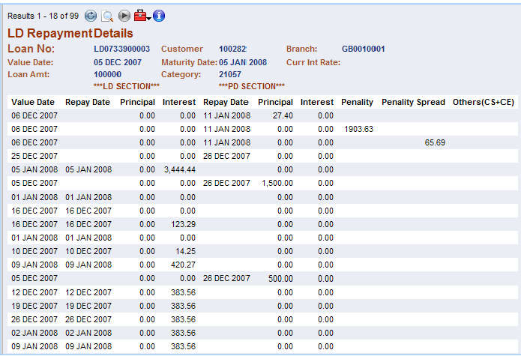
 | - Ideally a portfolio report to be generated with Customer name & ID, Group Sector, Approved amt, Disbursement amounts, Outstanding, NPLs, No of months in arrears, Undisbursed commitments, Maturities |  | 5 | Supported by similar standard T24 enquiries and reports, one of which is shown below.  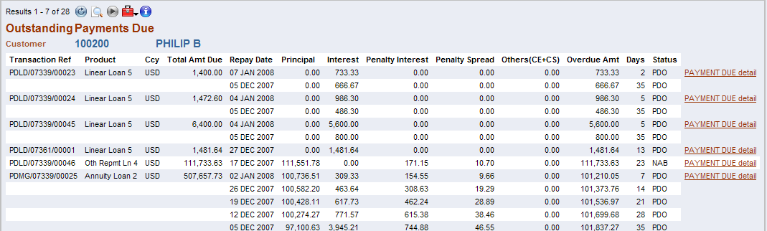
4. | Provisioning | 1
 | Provisioning data for all facilities & to provide information such as client name, O/S balance, months in arrears, security type, value, CBSL provision, judgemental, gap in provision, valuation date and for next valuation date to be flagged and be able to obtain a report |  | 4 or 5 | Handled by the provisioning tables in T24. The tables are LN.ASSET.CLASS and ASSET.CLASS .PARAMETER. Suggest NDB study these tables and gauge whether they meet the requirements here.
5. | MIS Area Restrictions | 1
 | MIS area availability period to be extended and a back up source to be available to retrieve past data for at least for the previous 2-3 years. At present only the previous month is available. |  | 5 | Supported by T24 MI module provided the data are stored online.
6. | Customer Ratings | 1
 | A risk rating model should be in place for corporates where a customer rating and also a facility rating could be accommodated on basis of quantitative and qualitative criteria |  | 4 or 5 | Risk rating is included in the T24 CRM module. A local sub-routine may be needed to be developed to accommodate the criteria specifically required by NDB.
7. | Rating Migration | 1
 | A report is needed to obtain the rating migration for at least 5 years with fields such as customer name, customer code, dates of rating and the Risk rating, remarks etc. |  | 4 | Presumably the report is to be based on the local specifications of NDB. As such, definition of the report is required.
8. | NPL Contracts on New NPL Classification | 1
 | - Need to improve the system to get the NPL contracts based on the NEW NPL classifications of the CB on the products operating. This should be inclusive of the grouping contracts as well with a separate identification of the other grouping contracts of different products. Also there should be flexibility to adjust those based on CB guidelines from time to time.  - NPL contracts to be classified as per the CBSL guidelines and to obtain a report  - Suspension of interest on NPLs |  | 4 or 5 | Handled by T24 Past Due module. The NPL classifications are user definable in T24.
9. | Basel information Requirements | 1
 | Please refer Annex I |  | 3 or 4 | Some local customization is required.

